LAPORAN PENGERJAAN UJI KOMPETENSI KEJURUAN SMK MAHARDHIKA BATUJAJAR

TAHUN PELAJARAN 2022-2023

KOMPETENSI KEAHLIAN : Rekayasa Perangkat Lunak KELAS : XII RPL 1

NAMA LENGKAP : M Rizal Nurrachman

NIS :

PAKET SOAL : 3

JENIS APLIKASI : Website

ALOKASI WAKTU : 24 jam

# PENJADWALAN KEGIATAN

*Silahkan buat form penjadwalan dengan excel seperti yang pernah dicontohkan*

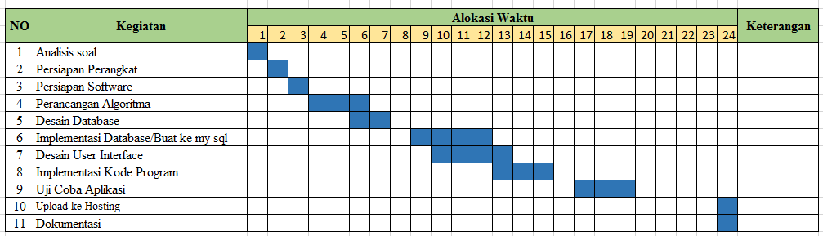

# PERSIAPAN PERANGKAT KERAS

*Silahkan isikan deskripsi/spesifikasi dari komputer/laptop yang kamu gunakan*

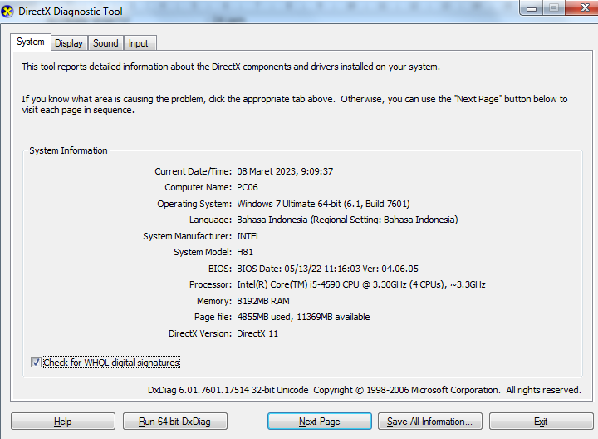

# PERSIAPAN PERANGKAT LUNAK

*Silahkan isikan perangkat lunak yang terlibat dalam pembuatan project ini*

1. *Visual Studio Code*
2. *Xamp Controller Panel*
3. *Google crome*
4. *Balsamiq Mockup*
5. *Astah Profesional*
6. *Excel 2010*

# PERANCANGAN ALGORITMA APLIKASI

*Silakan gambarkan activity diagram aplikasi yang kamu buat*

1. *Kasir konfirmasi pembayaran*

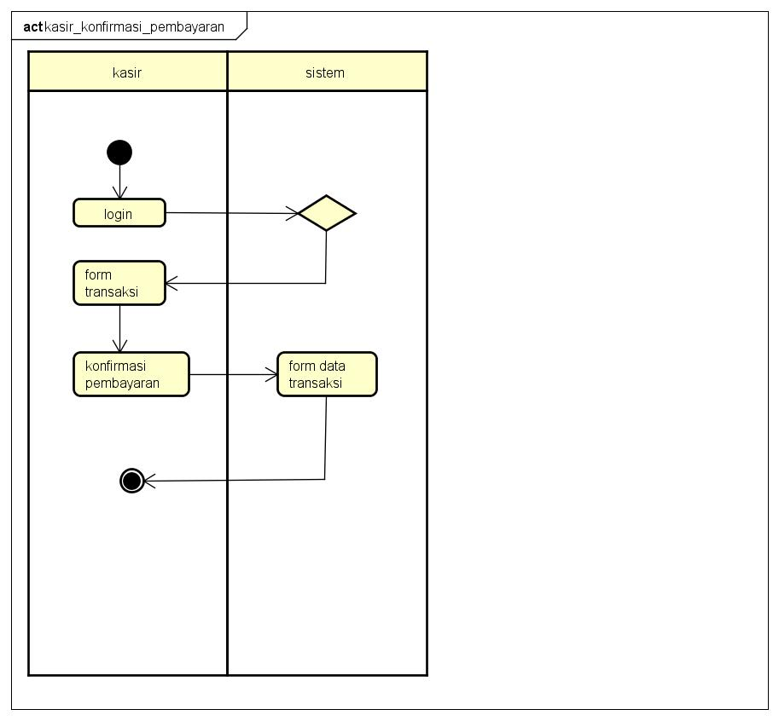

1. *Kasir laporan*

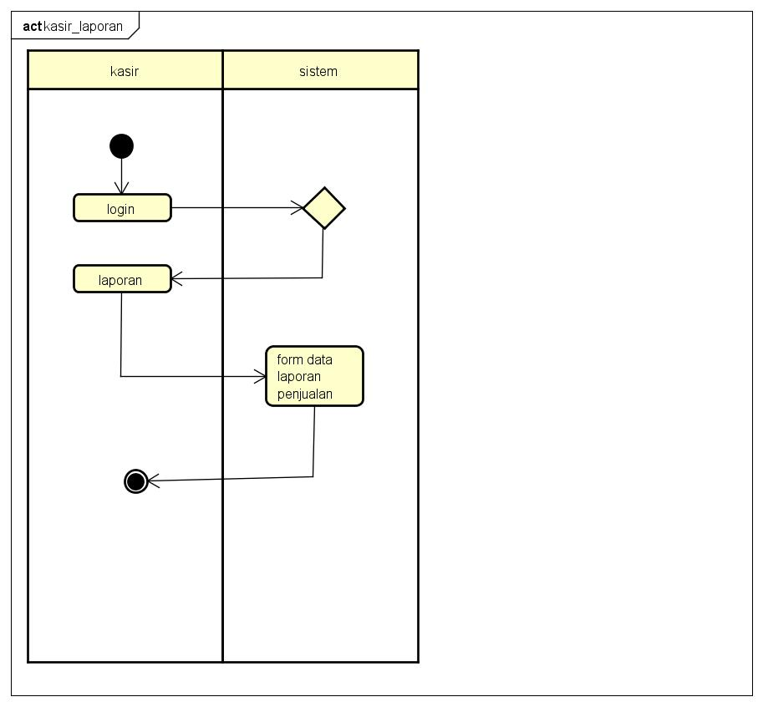

1. *Cetak laporan*

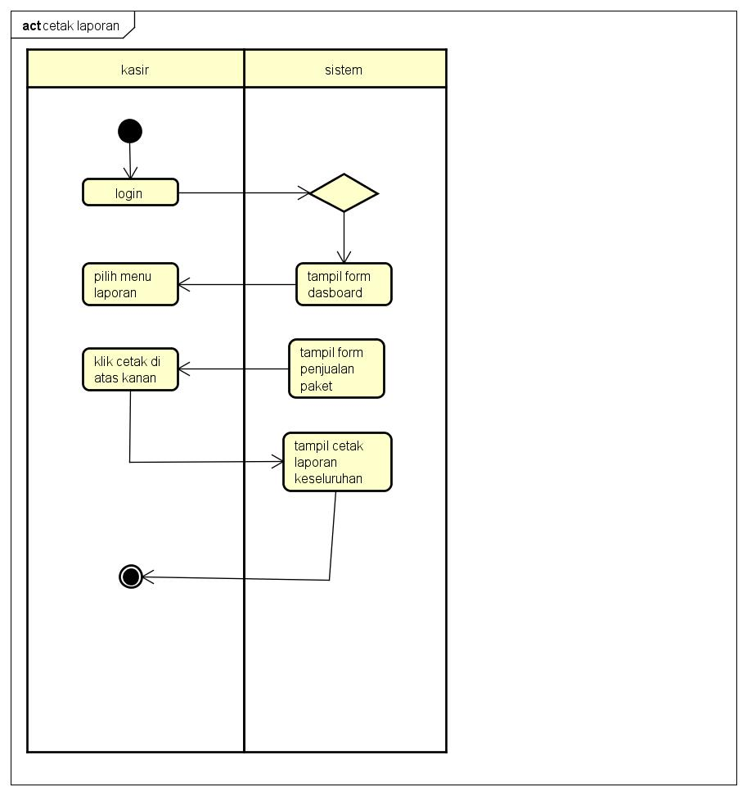

1. *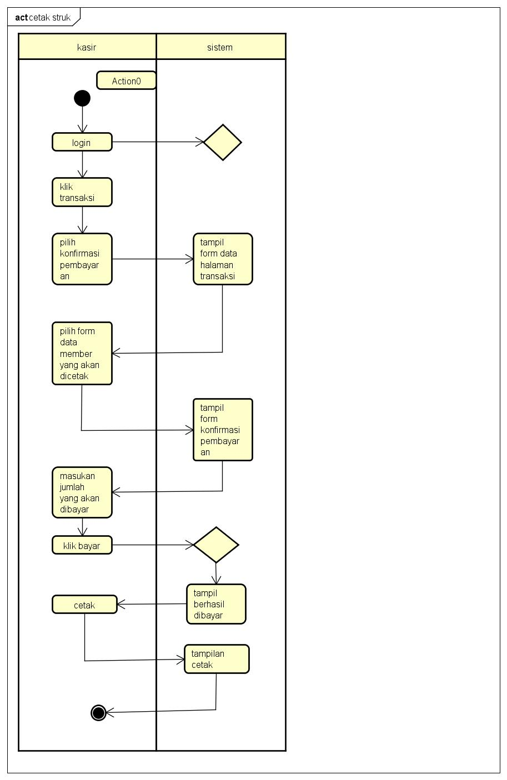Cetak struk*
2. *Kasir laporan*

**

1. *Kasir tambah pelanggan*

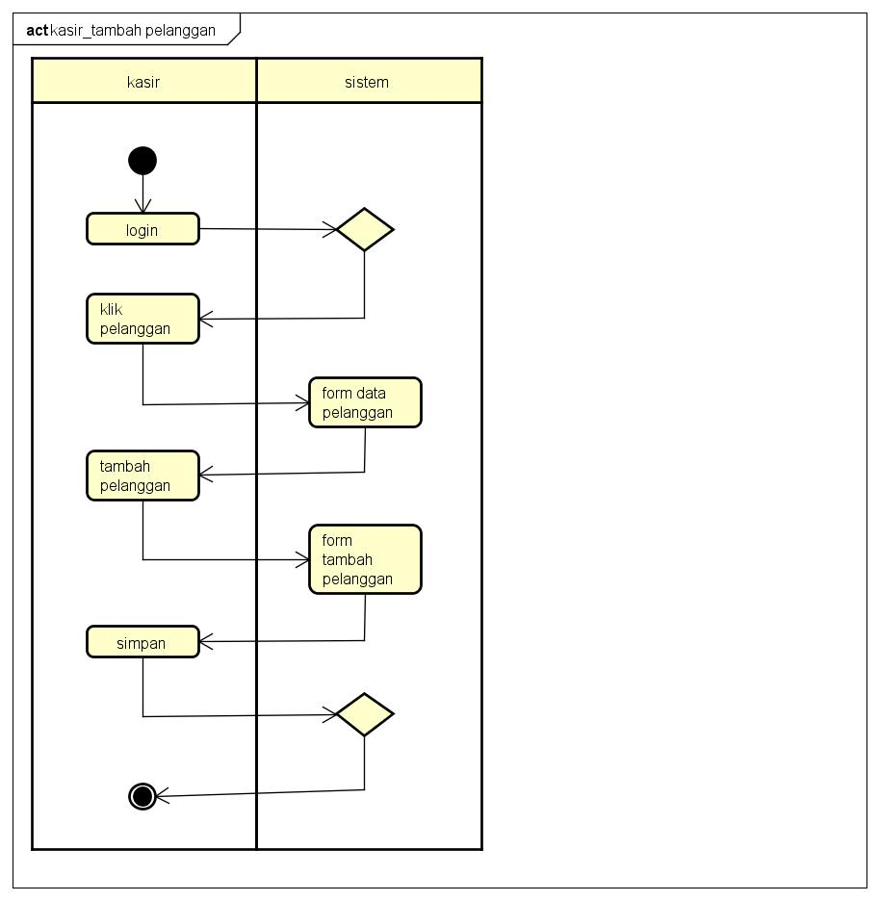

1. *Kasir transaksi*

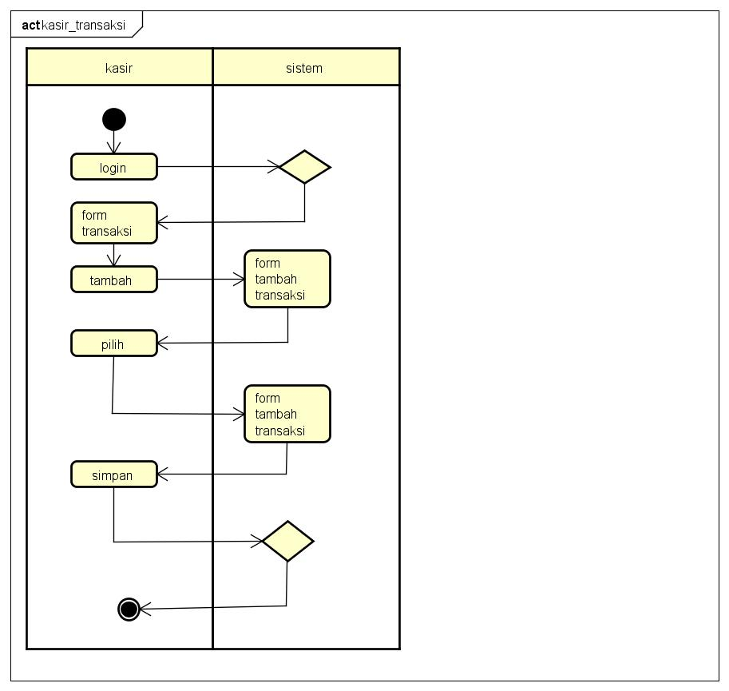

1. *Login kasir berhasil*

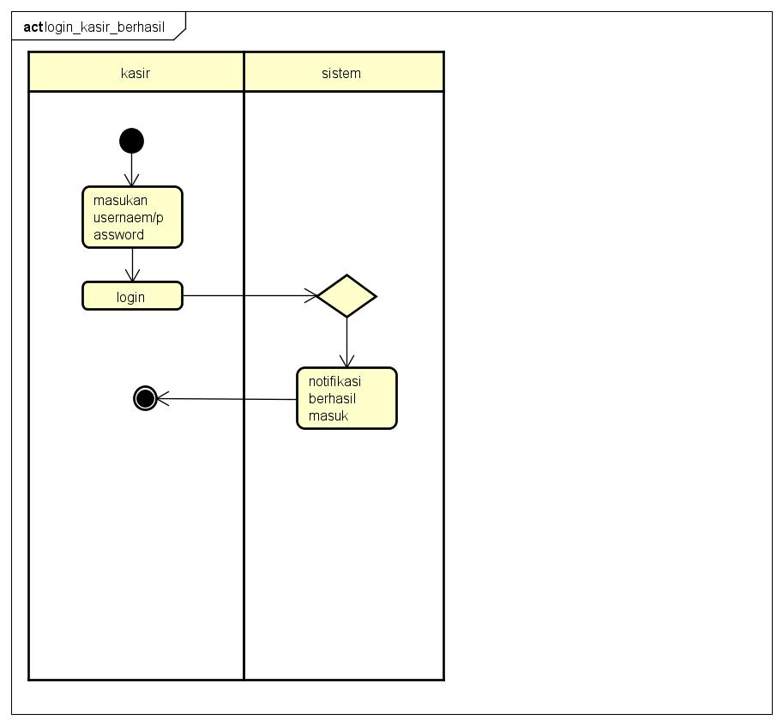

# PERANCANGAN DESAIN BASIS DATA

*Silahkan gambarkan ERD/DFD/class diagram atau desain basis data pada phpMyAdmin beserta relasin*

1. 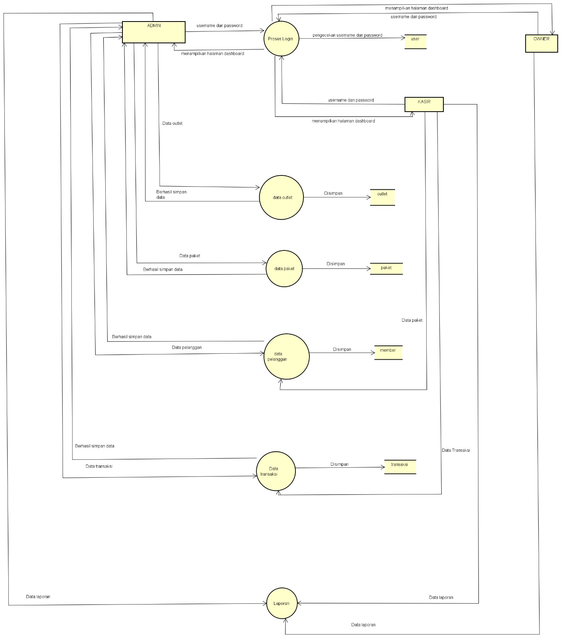DFD
2. *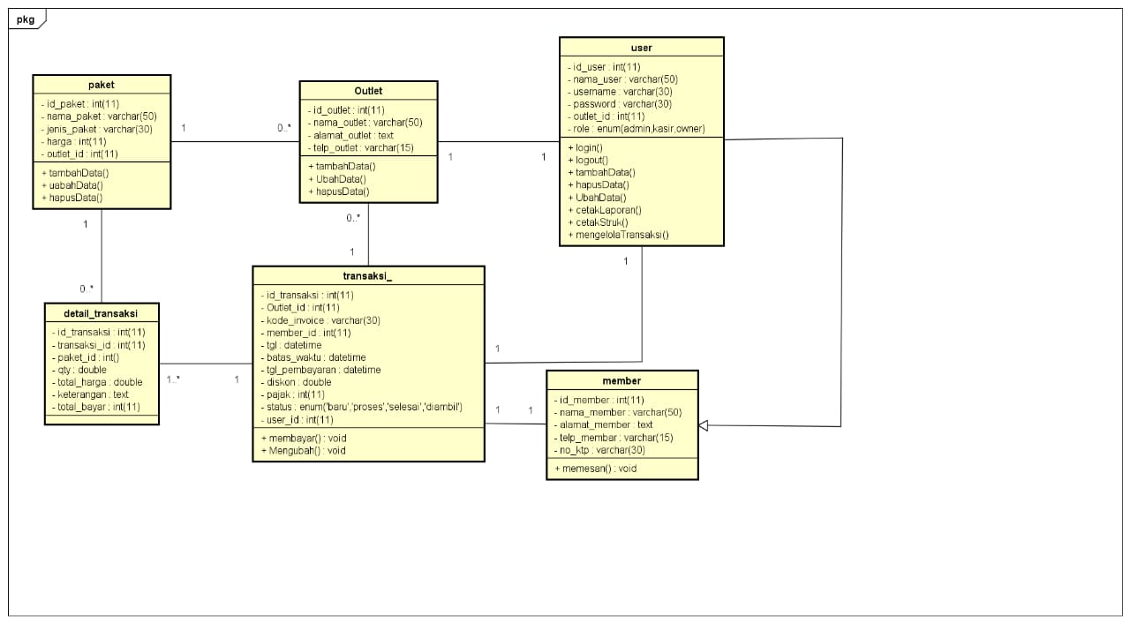Class diagram*

# DUMMY DATA

*Buat data dummy/bohongan yang dipersiapkan untuk nanti dimasukkan*

1. *user*

|  |  |  |  |  |  |
| --- | --- | --- | --- | --- | --- |
| **Id_user** | **Nama_user** | **username** | **password** | **Outlet_id** | **role** |
| 1 | Akulaku | Jaja | 12345 | 21 | Admin |
| 3 | Jamal | Jamal1 | 12345 | 13 | Kasir |
| 45 | Samsudin | Samsu | 12343 | 12 | Owner |
| 6 | Kajha | Jhaha | 1234 | 23 | admin |
| 1 | lisaa | lisaa | 324324 | 25 | kasir |

1. *paket*

|  |  |  |  |  |
| --- | --- | --- | --- | --- |
| **Id_paket** | **Jenis_paket** | **Nama_paket** | **Harga** | **Outlet_id** |
| 4 | Kiloan | Paket kering | 15.000 | 21 |
| 3 | Kiloan | Paket kering | 15.000 | 42 |
| 41 | Kiloan | Paket selimut | 20.000 | 34 |
| 9 | Kiloan | Paket selimut | 20.000 | 12 |
| 1 | Kiloan | Paket selimut | 20.000 | 25 |

1. *outlet*

|  |  |  |  |
| --- | --- | --- | --- |
| **Id_outlet** | **Nama_Outlet** | **Alamat_outlet** | **Telp_outlet** |
| 43 | Outlet mawar | yogyakarta | 08572323231 |
| 10 | Outlet Komang | Bandung | 08572323241 |
| 41 | Outlet Semar | Jakarta | 08572323333 |
| 11 | Outlet Jarot | Cihanjuang | 08572323215 |
| 22 | Outlet rizal | Jalantir | 08572322222 |

1. *member*

|  |  |  |  |  |  |
| --- | --- | --- | --- | --- | --- |
| **Id_member** | **Nama_member** | **Alamat_member** | **Jenis_kelami** | **Telp_member** | **No_ktp** |
| 5 | Koncomu | Semarang | L | 08512323111 | 32343443 |
| 3 | langsat | Jamal1 | 12345 | 08514323333 | 32343234 |
| 4 | komar | Samsu | 12343 | 08515323414 | 32343231 |
| 1 | dadang | Jhaha | 1234 | 08519323101 | 32343332 |
| 2 | danang | lisaa | 324324 | 08510323219 | 32343445 |

# PEMBUATAN BASIS DATA (MySQL Code)

*Silahkan buat basis data di PHPMyAdmin, jika sudah selesai bisa di copykan filenya di sini sebagai lampiran (*screenshot struktur tabel pada basis data yg dibuat)*

1. *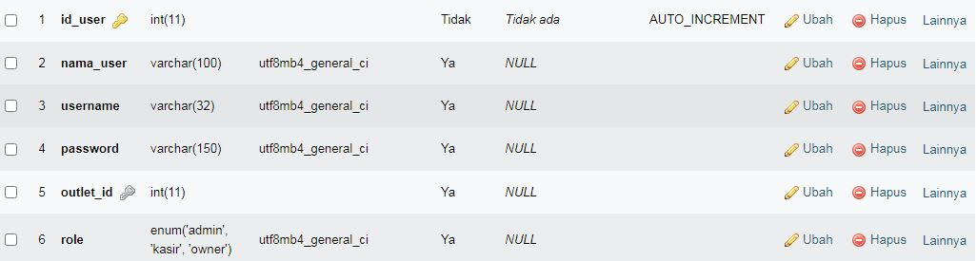User*
2. *Transaksi*

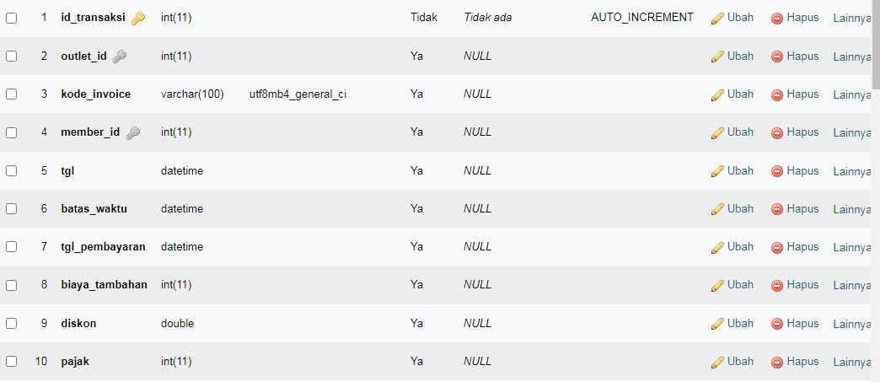

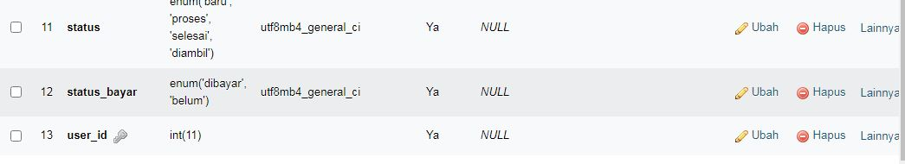

1. *Paket*

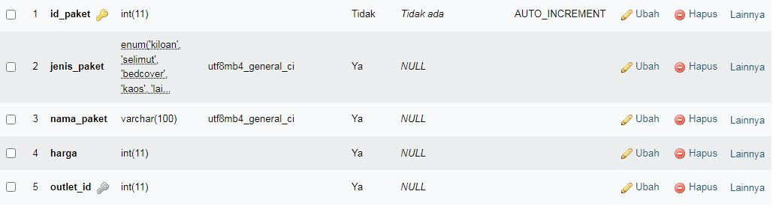

1. *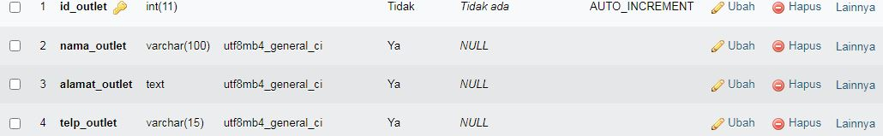Outlet*
2. *Member*
3. *Detail transaksi*

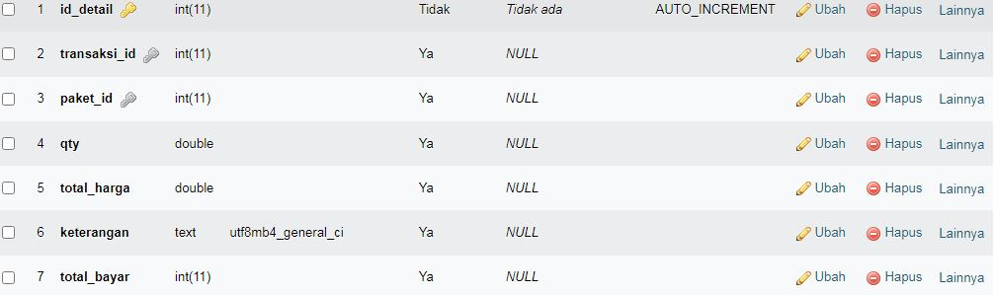

# 8. Aplikasi pengelolaan laundry

1. *Silahkan gambarkan use case diagram aplikasi yang kamu buat*

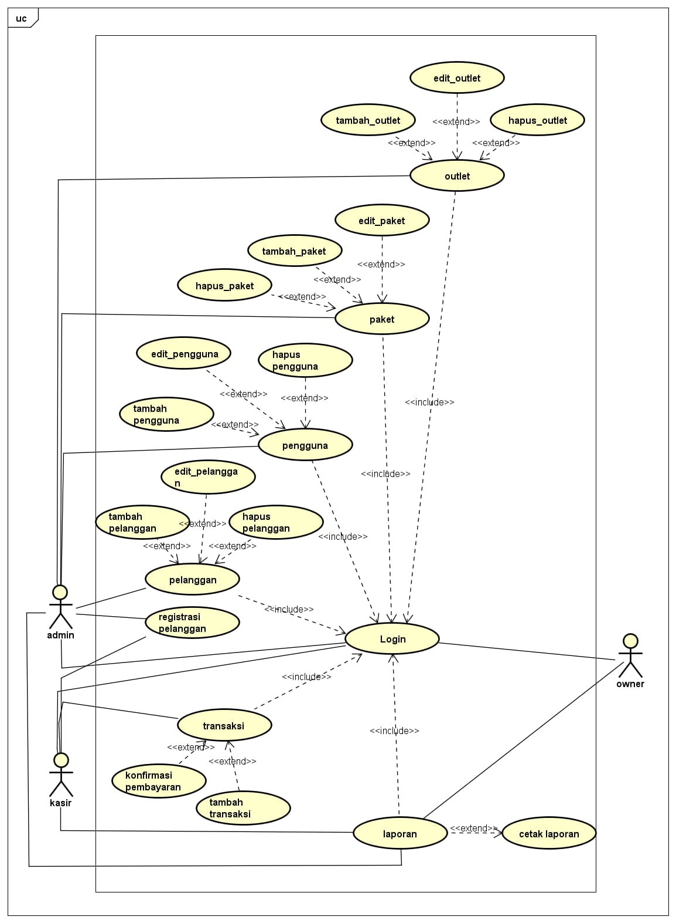

1. Admin dashboard

Tampilan untuk full manage semua data, buatkan sketsa/mockup-nya

1. 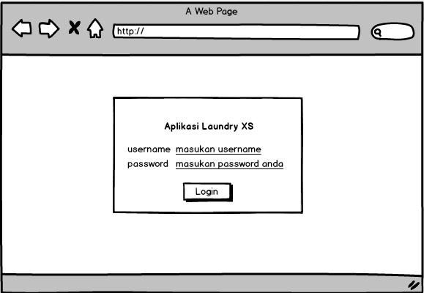Tampilan login
2. Dasboard

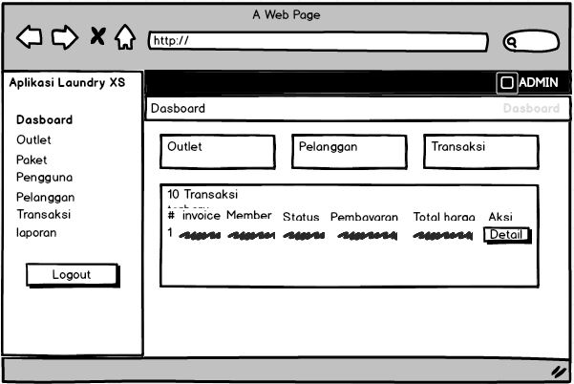

1. Tampil transaksi

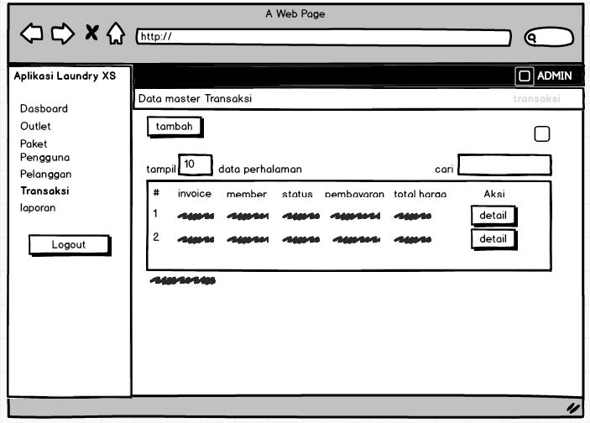

1. 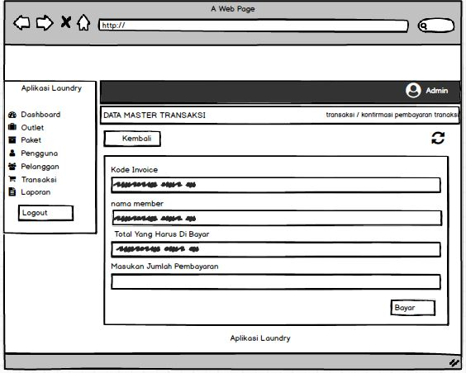Tampil bayar
2. Tambah paket

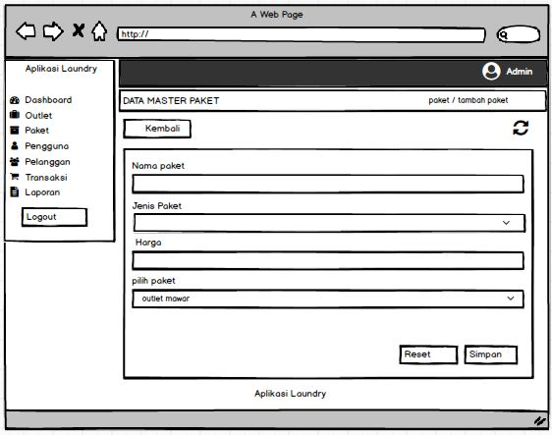

1. Edit paket

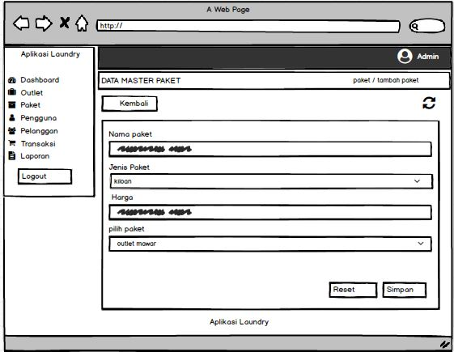

1. Transaksi bayar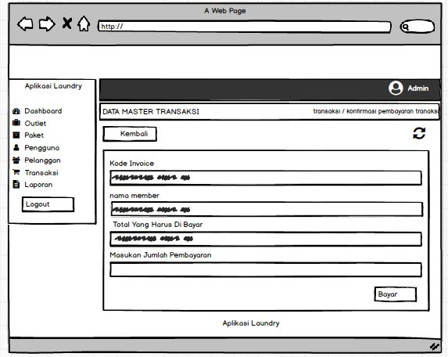
2. Transaksi dibayar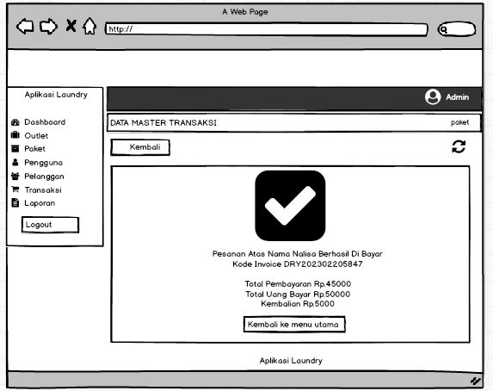
3. Transaksi cari member

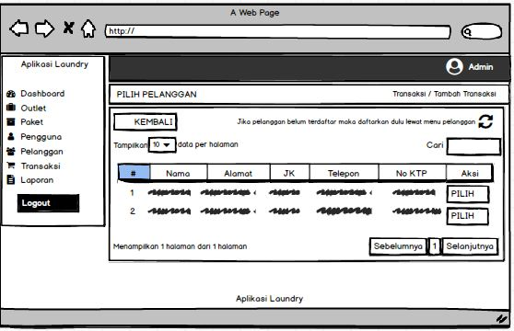

1. Tampilan Kasir

Setiap menu buatkan sketsa/mockup-nya

1. Tampil login
2. Transaksi
3. Transaksi tambah

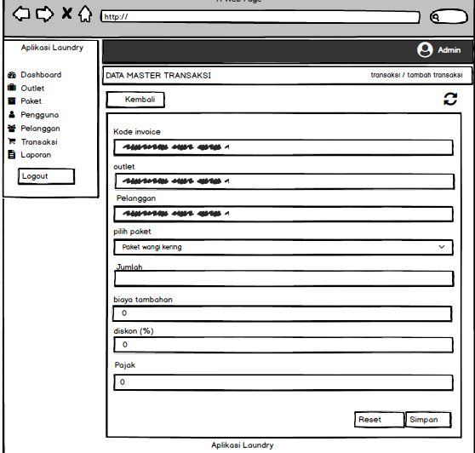

1. 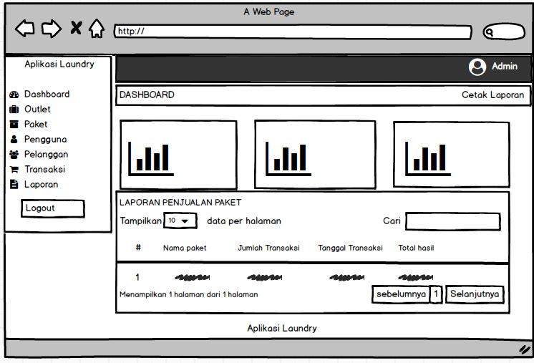Laporan
2. Konfirmasi pembayaran

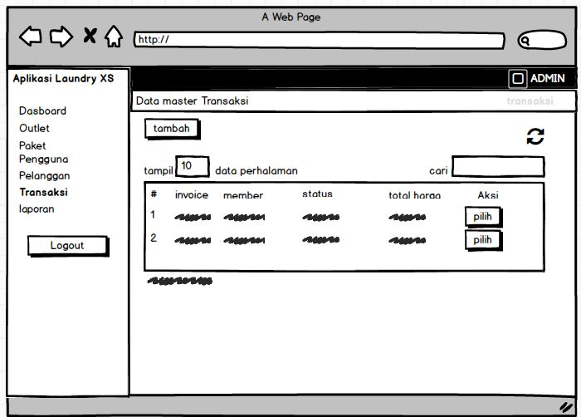

1. Tampil pelanggan

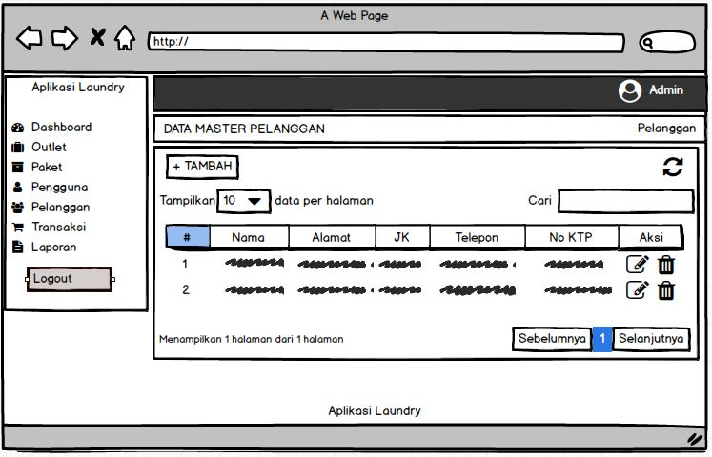

1. Tambah pelanggan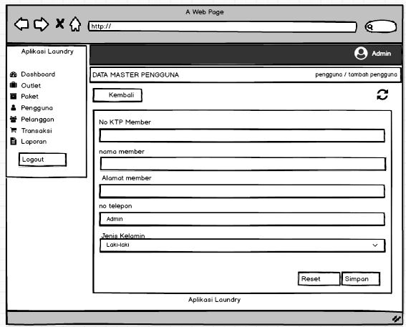
2. Detail transaksi

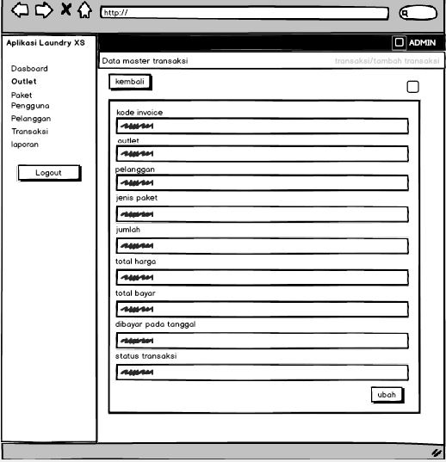

1. 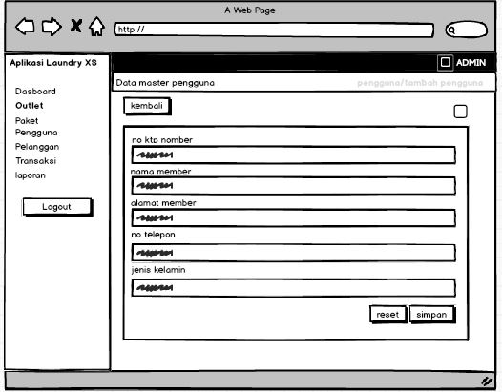Edit pelanggan
2. Tampilan owner

Setiap menu buatkan sketsa/mockup-nya

1. login
2. Dasboard
3. Laporan

# PEMBUATAN STRUKTUR WEB (HTML)

1. PEMBUATAN STYLE WEB (CSS) File style.css

.preloader{

position: relative;

margin: 0 auto;

width: 100px;

}

.preloader:before{

content: '';

display: block;

padding-top: 100%;

}

.circular {

animation: rotate 2s linear infinite;

height: 50px;

transform-origin: center center;

width: 50px;

position: absolute;

top: 0;

bottom: 0;

left: 0;

right: 0;

margin: auto;

}

.path {

stroke-dasharray: 1, 200;

stroke-dashoffset: 0;

animation: dash 1.5s ease-in-out infinite, color 6s ease-in-out infinite;

stroke-linecap: round;

}

@keyframes rotate {

100% {

transform: rotate(360deg);

}

}

@keyframes dash {

0% {

stroke-dasharray: 1, 200;

stroke-dashoffset: 0;

}

50% {

stroke-dasharray: 89, 200;

stroke-dashoffset: -35px;

}

100% {

stroke-dasharray: 89, 200;

stroke-dashoffset: -124px;

}

}

@keyframes color {

100%,

0% {

stroke: #d62d20;

}

40% {

stroke: #0057e7;

}

66% {

stroke: #008744;

}

80%,

90% {

stroke: #ffa700;

}

}

1. Style.css color

@import url(https://fonts.googleapis.com/css?family=Rubik:300,400,500,700,900);

/*Theme Colors*/

/*bootstrap Color*/

/*Normal Color*/

/*Border radius*/

/*Preloader*/

.preloader {

width: 100%;

height: 100%;

top: 0px;

position: fixed;

z-index: 99999;

background: #fff;

}

.preloader .cssload-speeding-wheel {

position: absolute;

top: calc(50% - 3.5px);

left: calc(50% - 3.5px);

}

/*Just change your choise color here its theme Colors*/

body {

background: #fff;

}

.top-left-part {

background: #fff;

}

.top-left-part .dark-logo {

display: none;

}

.top-left-part .light-logo {

display: inline-block;

}

/*Top Header Part*/

.logo i {

color: #ffffff;

}

.navbar-header {

background: #2f323e;

}

.navbar-top-links > li > a {

color: #ffffff;

}

.sidebar .sidebar-head {

background: #ffffff;

}

.sidebar .sidebar-head h3 {

color: #686868;

}

/*Right panel*/

.right-sidebar .rpanel-title {

background: #41b3f9;

}

/*Bread Crumb*/

.bg-title .breadcrumb .active {

color: #41b3f9;

}

/*Sidebar*/

.sidebar {

background: #fff;

box-shadow: 1px 0px 20px rgba(0, 0, 0, 0.08);

}

.sidebar .label-custom {

background: #01c0c8;

}

#side-menu li a {

color: #54667a;

}

#side-menu li a {

color: #54667a;

border-left: 0px solid #fff;

}

#side-menu > li > a {

border-left: 3px solid transperant;

}

#side-menu > li > a:hover,

#side-menu > li > a:focus {

background: rgba(0, 0, 0, 0.07);

}

#side-menu > li > a.active {

background: transperant;

color: #54667a;

border-left: 3px solid #41b3f9;

font-weight: 500;

}

#side-menu ul > li > a:hover {

color: #41b3f9;

}

#side-menu ul > li > a.active {

color: #54667a;

font-weight: 500;

}

.user-profile .user-pro-body .u-dropdown {

color: #54667a;

}

/*themecolor*/

.bg-theme {

background-color: #707cd2 !important;

}

.bg-theme-dark {

background-color: #41b3f9 !important;

}

/*Button*/

.btn-custom {

background: #41b3f9;

border: 1px solid #41b3f9;

color: #ffffff;

}

.btn-custom:hover {

background: #41b3f9;

opacity: 0.8;

color: #ffffff;

border: 1px solid #41b3f9;

}

/*Custom tab*/

.customtab li.active a,

.customtab li.active a:hover,

.customtab li.active a:focus {

border-bottom: 2px solid #41b3f9;

color: #41b3f9;

}

.tabs-vertical li.active a,

.tabs-vertical li.active a:hover,

.tabs-vertical li.active a:focus {

background: #41b3f9;

border-right: 2px solid #41b3f9;

}

/*Nav-pills*/

.nav-pills > li.active > a,

.nav-pills > li.active > a:focus,

.nav-pills > li.active > a:hover {

background: #41b3f9;

color: #ffffff;

}

/*Extra css*/

.bg-theme {

background-color: #41b3f9 !important;

}

.panel-themecolor,

.panel-theme {

border-color: #41b3f9;

}

.panel-themecolor .panel-heading,

.panel-theme .panel-heading {

border-color: #41b3f9;

color: white;

background-color: #41b3f9;

}

.panel-themecolor .panel-heading a,

.panel-theme .panel-heading a {

color: #ffffff;

}

.panel-themecolor .panel-heading a:hover,

.panel-theme .panel-heading a:hover {

color: rgba(255, 255, 255, 0.5);

}

.panel-themecolor a,

.panel-theme a {

color: #41b3f9;

}

.panel-themecolor a:hover,

.panel-theme a:hover {

color: #0791e6;

}

1. PEMBUATAN KODE WEB (PHP/JS) **File index.php**

<?php

$title = 'dashboard';

require 'functions.php';

require 'layout_header.php';

$jTransaksi = ambilsatubaris($conn,'SELECT COUNT(id_transaksi) as jumlahtransaksi FROM transaksi');

$jPelanggan = ambilsatubaris($conn,'SELECT COUNT(id_member) as jumlahmember FROM member');

$joutlet = ambilsatubaris($conn,'SELECT COUNT(id_outlet) as jumlahoutlet FROM outlet');

$query = "SELECT transaksi.*,member.nama_member , detail_transaksi.total_harga FROM transaksi INNER JOIN member ON member.id_member = transaksi.member_id INNER JOIN detail_transaksi ON detail_transaksi.transaksi_id = transaksi.id_transaksi ORDER BY transaksi.id_transaksi DESC LIMIT 10";

$data = ambildata($conn,$query);

?>

<div class="container-fluid">

<div class="row bg-title">

<div class="col-lg-3 col-md-4 col-sm-4 col-xs-12">

<h4 class="page-title">Dashboard</h4> </div>

<div class="col-lg-9 col-sm-8 col-md-8 col-xs-12">

<ol class="breadcrumb">

<li><a href="#">Dashboard</a></li>

</ol>

</div>

<!-- /.col-lg-12 -->

</div>

<!-- /.row -->

<!-- ============================================================== -->

<!-- Different data widgets -->

<!-- ============================================================== -->

<!-- .row -->

<div class="row">

<div class="col-lg-4 col-sm-6 col-xs-12">

<div class="white-box analytics-info">

<h3 class="box-title">Oulet</h3>

<ul class="list-inline two-part">

<li>

<div id="sparklinedash"></div>

</li>

<li class="text-right"><i class="ti-arrow-up text-success"></i> <span class="counter text-success"><?= htmlspecialchars($joutlet['jumlahoutlet']); ?></span></li>

</ul>

</div>

</div>

<div class="col-lg-4 col-sm-6 col-xs-12">

<div class="white-box analytics-info">

<h3 class="box-title">Pelanggan</h3>

<ul class="list-inline two-part">

<li>

<div id="sparklinedash2"></div>

</li>

<li class="text-right"><i class="ti-arrow-up text-purple"></i> <span class="counter text-purple"><?= htmlspecialchars($jPelanggan['jumlahmember']); ?></span></li>

</ul>

</div>

</div>

<div class="col-lg-4 col-sm-6 col-xs-12">

<div class="white-box analytics-info">

<h3 class="box-title">Transaksi</h3>

<ul class="list-inline two-part">

<li>

<div id="sparklinedash3"></div>

</li>

<li class="text-right"><i class="ti-arrow-up text-info"></i> <span class="counter text-info"><?= htmlspecialchars($jTransaksi['jumlahtransaksi']); ?></span></li>

</ul>

</div>

</div>

</div>

<div class="row">

<div class="col-md-12 col-lg-12 col-sm-12">

<div class="white-box">

<h3 class="box-title">10 Transaksi Terbaru</h3>

<div class="table-responsive">

<table class="table ">

<thead>

<tr>

<th>#</th>

<th>Invoice</th>

<th>Member</th>

<th>Status</th>

<th>Pemabayaran</th>

<th>Total Harga</th>

<th width="15%">Aksi</th>

</tr>

</thead>

<tbody>

<?php $no=1; foreach($data as $transaksi): ?>

<tr>

<td><?= $no++ ?></td>

<td><?= htmlspecialchars($transaksi['kode_invoice']); ?></td>

<td><?= htmlspecialchars($transaksi['nama_member']); ?></td>

<td><?= htmlspecialchars($transaksi['status']); ?></td>

<td><?= htmlspecialchars($transaksi['status_bayar']); ?></td>

<td><?= htmlspecialchars($transaksi['total_harga']); ?></td>

<td align="center">

<a href="transaksi_detail.php?id=<?= htmlspecialchars($transaksi['id_transaksi']); ?>" data-toggle="tooltip" data-placement="bottom" title="Edit" class="btn btn-success btn-block">Detail</a>

</td>

</tr>

<?php endforeach; ?>

</tbody>

</table>

</div>

</div>

</div>

</div>

</div>

<?php

require 'layout_footer.php';

?>

**File koneksi.php**

<?php

session_start();

if($_SESSION){

if($_SESSION['role'] == 'admin'){

}else{

header('location:../index.php');

}

}else{

header('location:../index.php');

}

$conn = mysqli_connect('localhost','root','','db_laundrytes2');

function ambildata($conn,$query){

$data = mysqli_query($conn,$query);

if (mysqli_num_rows($data) > 0) {

while($row = mysqli_fetch_assoc($data)){

$hasil[] = $row;

}

return $hasil;

}

}

function bisa($conn,$query){

$db = mysqli_query($conn,$query);

if($db){

return 1;

}else{

return 0;

}

}

function ambilsatubaris($conn,$query){

$db = mysqli_query($conn,$query);

return mysqli_fetch_assoc($db);

}

function hapus($where,$table,$redirect){

$query = 'DELETE FROM ' . $table . ' WHERE ' . $where;

echo $query;

}

>?

**CRUD FILE**

<?php

$title = 'pengguna';

require'functions.php';

$tgl_sekarang = Date('Y-m-d h:i:s');

$tujuh_hari = mktime(0,0,0,date("n"),date("j")+7,date("Y"));

$batas_waktu = date("Y-m-d h:i:s", $tujuh_hari);

$invoice = 'DRY'.Date('Ymdsi');

$outlet_id = $_GET['outlet_id'];

$user_id = $_SESSION['user_id'];

$member_id = $_GET['id'];

$outlet = ambilsatubaris($conn,'SELECT nama_outlet from outlet WHERE id_outlet = ' . $outlet_id);

$member = ambilsatubaris($conn,'SELECT nama_member from member WHERE id_member = ' . $member_id);

$paket = ambildata($conn,'SELECT * FROM paket WHERE outlet_id = ' . $outlet_id);

if(isset($_POST['btn-simpan'])){

$kode_invoice = $_POST['kode_invoice'];

$biaya_tambahan = $_POST['biaya_tambahan'];

$diskon = $_POST['diskon'];

$pajak = $_POST['pajak'];

$query = "INSERT INTO transaksi (outlet_id,kode_invoice,member_id,tgl,batas_waktu,biaya_tambahan,diskon,pajak,status,status_bayar,user_id) VALUES

('$outlet_id','$kode_invoice','$member_id','$tgl_sekarang','$batas_waktu','$biaya_tambahan','$diskon','$pajak','baru','belum','$user_id')";

$execute = bisa($conn,$query);

if ($execute == 1) {

$paket_id = $_POST['paket_id'];

$qty = $_POST['qty'];

$hargapaket = ambilsatubaris($conn,'SELECT harga from paket WHERE id_paket = ' . $paket_id);

$total1 = $hargapaket['harga'] * $qty;

if($biaya_tambahan != 0 && $pajak != 0 && $diskon != 0){

$total3 = $total1 - ($total1 * $diskon / 100);

$total2 = $biaya_tambahan + $total3;

$total_harga = $total2 + ($total2 * $pajak / 100);

}elseif($biaya_tambahan != 0 && $diskon != 0){

$total2 = $total1 - ($total1 * $diskon / 100);

$total_harga = $biaya_tambahan + $total2;

}elseif($biaya_tambahan != 0 && $pajak != 0){

$total2 = $total1 + $biaya_tambahan;

$total_harga = $total2 + ($total2 * $pajak / 100);

}elseif($diskon != 0 && $pajak != 0){

$total2 = $total1 - ($total1 * $diskon / 100);

$total_harga = $total2 + ($total2 * $pajak / 100);

}elseif($biaya_tambahan != 0){

$total_harga = $total1 + $biaya_tambahan;

}elseif($diskon != 0){

$total_harga = $total1 - ($total1 * $diskon / 100);

}elseif($pajak != 0){

$total_harga = $total1 + ($total1 * $pajak / 100);

}else{

$total_harga = $total1;

}

$kode_invoice;

$transaksi = ambilsatubaris($conn,"SELECT * FROM transaksi WHERE kode_invoice = '" . $kode_invoice ."'");

$transaksi_id = $transaksi['id_transaksi'];

$sqlDetail = "INSERT INTO detail_transaksi (transaksi_id,paket_id,qty,total_harga) VALUES ('$transaksi_id','$paket_id','$qty','$total_harga')";

$executeDetail = bisa($conn,$sqlDetail);

if($executeDetail == 1){

header('location: transaksi_sukses.php?id='.$transaksi_id);

}else{

echo "Gagal Tambah Data";

}

}

}

require'layout_header.php';

?>

<div class="container-fluid">

<div class="row bg-title">

<div class="col-lg-3 col-md-4 col-sm-4 col-xs-12">

<h4 class="page-title">Data Master Transaksi</h4> </div>

<div class="col-lg-9 col-sm-8 col-md-8 col-xs-12">

<ol class="breadcrumb">

<li><a href="outlet.php">Transaksi</a></li>

<li><a href="#">Tambah Transaksi</a></li>

</ol>

</div>

<!-- /.col-lg-12 -->

</div>

<div class="row">

<div class="col-md-12 col-lg-12 col-sm-12 col-xs-12">

<div class="white-box">

<div class="row">

<div class="col-md-6">

<a href="javascript:void(0)" onclick="window.history.back();" class="btn btn-primary box-title"><i class="fa fa-arrow-left fa-fw"></i> Kembali</a>

</div>

<div class="col-md-6 text-right">

<button id="btn-refresh" class="btn btn-primary box-title text-right" title="Refresh Data"><i class="fa fa-refresh" id="ic-refresh"></i></button>

</div>

</div>

</div>

</div>

</div>

<div class="row">

<div class="col-md-12 col-lg-12 col-sm-12 col-xs-12">

<div class="white-box">

<form method="post" action="">

<div class="form-group">

<label>Kode Invoice</label>

<input type="text" name="kode_invoice" class="form-control" readonly="" value="<?= $invoice ?>">

</div>

<div class="form-group">

<label>Outlet</label>

<input type="text" name="username" class="form-control" readonly="" value="<?= $outlet['nama_outlet'] ?>">

</div>

<div class="form-group">

<label>Pelanggan</label>

<input type="text" name="password" class="form-control" readonly="" value="<?= $member['nama_member'] ?>">

</div>

<div class="form-group">

<label>Pilih Paket</label>

<select name="paket_id" class="form-control">

<?php foreach ($paket as $key): ?>

<option value="<?= $key['id_paket'] ?>"><?= $key['nama_paket']; ?></option>

<?php endforeach ?>

</select>

</div>

<div class="form-group">

<label>Jumlah</label>

<input type="text" name="qty" class="form-control">

</div>

<div class="form-group">

<label>Biaya Tambahan</label>

<input type="text" name="biaya_tambahan" class="form-control" value="0">

</div>

<div class="form-group">

<label>Diskon (%)</label>

<input type="text" name="diskon" class="form-control" value="0">

</div>

<div class="form-group">

<label>Pajak</label>

<input type="text" name="pajak" class="form-control" value="0">

</div>

<div class="text-right">

<button type="reset" class="btn btn-danger">Reset</button>

<button type="submit" name="btn-simpan" class="btn btn-primary">Simpan</button>

</div>

</form>

</div>

</div>

</div>

</div>

<?php

require'layout_footer.php';

?>

<?php

$title = 'paket';

require'functions.php';

$query = 'SELECT * FROM outlet';

$data = ambildata($conn,$query);

if(isset($_POST['btn-simpan'])){

$nama = stripslashes($_POST['nama_paket']);

$jenis_paket = stripslashes($_POST['jenis_paket']);

$harga = stripslashes($_POST['harga']);

$outlet_id = stripslashes($_POST['outlet_id']);

$query = "INSERT INTO paket (nama_paket,jenis_paket,harga,outlet_id) values ('$nama','$jenis_paket','$harga','$outlet_id')";

$execute = bisa($conn,$query);

if($execute == 1){

$success = 'true';

$title = 'Berhasil';

$message = 'Berhasil Simpan Data';

$type = 'success';

header('location: paket.php?crud='.$success.'&msg='.$message.'&type='.$type.'&title='.$title);

}else{

echo "Gagal Tambah Data";

}

}

require'layout_header.php';

?>

<div class="container-fluid">

<div class="row bg-title">

<div class="col-lg-3 col-md-4 col-sm-4 col-xs-12">

<h4 class="page-title">Data Master <?= htmlspecialchars($title); ?></h4> </div>

<div class="col-lg-9 col-sm-8 col-md-8 col-xs-12">

<ol class="breadcrumb">

<li><a href="outlet.php"><?= htmlspecialchars($title); ?></a></li>

<li><a href="#">Tambah <?= htmlspecialchars($title); ?></a></li>

</ol>

</div>

<!-- /.col-lg-12 -->

</div>

<div class="row">

<div class="col-md-12 col-lg-12 col-sm-12 col-xs-12">

<div class="white-box">

<div class="row">

<div class="col-md-6">

<a href="javascript:void(0)" onclick="window.history.back();" class="btn btn-primary box-title"><i class="fa fa-arrow-left fa-fw"></i> Kembali</a>

</div>

<div class="col-md-6 text-right">

<button id="btn-refresh" class="btn btn-primary box-title text-right" title="Refresh Data"><i class="fa fa-refresh" id="ic-refresh"></i></button>

</div>

</div>

</div>

</div>

</div>

<div class="row">

<div class="col-md-12 col-lg-12 col-sm-12 col-xs-12">

<div class="white-box">

<form method="post" action="">

<div class="form-group">

<label>Nama Paket</label>

<input type="text" name="nama_paket" class="form-control">

</div>

<div class="form-group">

<label>Jenis Paket</label>

<select name="jenis_paket" class="form-control">

<option value="kiloan">kiloan</option>

<option value="selimut">selimut</option>

<option value="bedcover">bedcover</option>

<option value="kiloan">kiloan</option>

<option value="kaos">kaos</option>

<option value="lain">lain</option>

</select>

</div>

<div class="form-group">

<label>Harga</label>

<input type="text" name="harga" class="form-control">

</div>

<div class="form-group">

<label>Pilih Outlet</label>

<select name="outlet_id" class="form-control">

<?php foreach ($data as $outlet): ?>

<option value="<?= $outlet['id_outlet'] ?>"><?= htmlspecialchars($outlet['nama_outlet']); ?></option>

<?php endforeach ?>

</select>

</div>

<div class="text-right">

<button type="reset" class="btn btn-danger">Reset</button>

<button type="submit" name="btn-simpan" class="btn btn-primary">Simpan</button>

</div>

</form>

</div>

</div>

</div>

</div>

<?php

require'layout_footer.php';

?>

<?php

require 'functions.php';

$sql = "DELETE FROM paket WHERE id_paket = " . stripslashes($_GET['id']);

$exe = mysqli_query($conn,$sql);

if($exe){

$success = 'true';

$title = 'Berhasil';

$message = 'Menghapus Data';

$type = 'success';

header('location: paket.php?crud='.$success.'&msg='.$message.'&type='.$type.'&title='.$title);

}

<?php

$title = 'paket';

require'functions.php';

$jenis = ['kiloan','selimut','bedcover','kaos','lain'];

$id_paket = stripslashes($_GET['id']);

$queryedit = "SELECT * FROM paket WHERE id_paket = '$id_paket'";

$edit = ambilsatubaris($conn,$queryedit);

var_dump($edit);

$query = 'SELECT * FROM outlet';

$data = ambildata($conn,$query);

if(isset($_POST['btn-simpan'])){

$nama = stripslashes($_POST['nama_paket']);

$jenis_paket = stripslashes($_POST['jenis_paket']);

$harga = stripslashes($_POST['harga']);

$outlet_id = stripslashes($_POST['outlet_id']);

$query = "UPDATE paket SET nama_paket='$nama',jenis_paket='$jenis_paket',harga='$harga',outlet_id='$outlet_id' WHERE id_paket = '$id_paket'";

$execute = bisa($conn,$query);

if($execute == 1){

$success = 'true';

$title = 'Berhasil';

$message = 'Berhasil Ubah Data';

$type = 'success';

header('location: paket.php?crud='.$success.'&msg='.$message.'&type='.$type.'&title='.$title);

}else{

echo "Gagal Tambah Data";

}

}

require'layout_header.php';

?>

<div class="container-fluid">

<div class="row bg-title">

<div class="col-lg-3 col-md-4 col-sm-4 col-xs-12">

<h4 class="page-title">Data Master <?= htmlspecialchars($title); ?></h4> </div>

<div class="col-lg-9 col-sm-8 col-md-8 col-xs-12">

<ol class="breadcrumb">

<li><a href="outlet.php"><?= htmlspecialchars($title); ?></a></li>

<li><a href="#">Tambah <?= htmlspecialchars($title); ?></a></li>

</ol>

</div>

<!-- /.col-lg-12 -->

</div>

<div class="row">

<div class="col-md-12 col-lg-12 col-sm-12 col-xs-12">

<div class="white-box">

<div class="row">

<div class="col-md-6">

<a href="javascript:void(0)" onclick="window.history.back();" class="btn btn-primary box-title"><i class="fa fa-arrow-left fa-fw"></i> Kembali</a>

</div>

<div class="col-md-6 text-right">

<button id="btn-refresh" class="btn btn-primary box-title text-right" title="Refresh Data"><i class="fa fa-refresh" id="ic-refresh"></i></button>

</div>

</div>

</div>

</div>

</div>

<div class="row">

<div class="col-md-12 col-lg-12 col-sm-12 col-xs-12">

<div class="white-box">

<form method="post" action="">

<div class="form-group">

<label>Nama Paket</label>

<input type="text" name="nama_paket" class="form-control" value="<?= htmlspecialchars($edit['nama_paket']); ?>">

</div>

<div class="form-group">

<label>Jenis Paket</label>

<select name="jenis_paket" class="form-control">

<?php foreach ($jenis as $key): ?>

<?php if ($key == $edit['jenis_paket']): ?>

<option value="<?= htmlspecialchars($key); ?>" selected><?= htmlspecialchars($key); ?></option>

<?php endif ?>

<option value="<?= htmlspecialchars($key); ?>"><?= htmlspecialchars($key); ?></option>

<?php endforeach ?>

</select>

</div>

<div class="form-group">

<label>Harga</label>

<input type="text" name="harga" class="form-control" value="<?= htmlspecialchars($edit['harga']); ?>">

</div>

<div class="form-group">

<label>Pilih Outlet</label>

<select name="outlet_id" class="form-control">

<?php foreach ($data as $outlet): ?>

<?php if ($data['id_outlet'] == $edit['outlet_id']): ?>

<option value="<?= htmlspecialchars($outlet['id_outlet']); ?>" selected><?= htmlspecialchars($outlet['nama_outlet']); ?></option>

<?php endif ?>

<option value="<?= htmlspecialchars($outlet['id_outlet']); ?>"><?= htmlspecialchars($outlet['nama_outlet']); ?></option>

<?php endforeach ?>

</select>

</div>

<div class="text-right">

<button type="reset" class="btn btn-danger">Reset</button>

<button type="submit" name="btn-simpan" class="btn btn-primary">Simpan</button>

</div>

</form>

</div>

</div>

</div>

</div>

<?php

require'layout_footer.php';

?>

1. 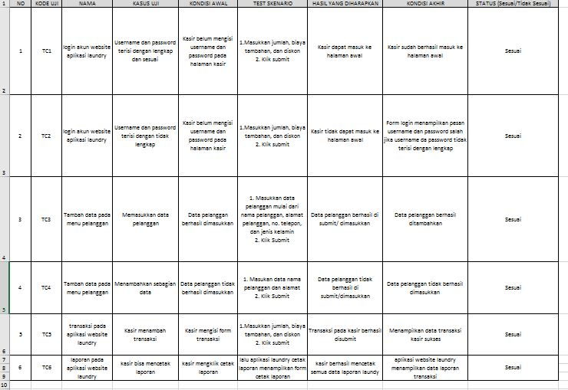UJI COBA
2. REVISI
3. PENENTUAN DOMAIN DAN HOSTING
4. UPLOAD WEB KE HOSTING
5. UPLOAD WEB KE GITHUB
6. PEMBUATAN USER GUIDANCE